Project Proposal

fewd42 - Kira Ugai 🡪 https://wireframe.cc/q4MFnw

For my final project, I would like to create a landing page for my parent’s business. My parents own a beauty wholesale business and have been operating for over 15 years. They recently decided to update their webshop but besides having the webshop page (where they sell their products), they also wanted to have a separate landing page for their business (which will showcase their company’s story, clients and more).

The overall concept for this landing page is to be user friendly, simple (but elegant) and it has to include several important elements – in the navigation menu:

* **About Us (in Dutch ‘Over Ons’):**

This page will tell the users more about the company: *their culture, their vision and their mission*.

* **Showroom:**

This page will showcase the company’s showroom.

* **Workshops:**

This page will list the workshop’s the company provides.

* **Conference Agenda (in Dutch ‘Beursagenda’):**

This page will list the conferences the company will attend in the near future.

* **LINK TO THE WEBSHOP**

A link to the website self. This has to be noticeable and emerge on every page of the landing page.

* **Yellow Rose Cosmetics:**

This page will showcase the company’s main product line.

* **Contact + Careers**

This page will list contact information such as e-mail, phone, address and openinghours.

* **Subscription Option (in Dutch ‘Nieuwsbrief’):**

This has to be included somewhere in the center of the page and emerge on every other page.

* **Social Media Icons**

**The landing page has to be responsive:** mobile, pc and tablet.

**Logo: **

**Colors landing page:** white (background), black (font) | gray (rest of font when you do a mouseover), ### (detailing, yet to decide the color).

**Audience consists of the following customers:**

* Beauticians (individuals)
* Beauty salons
* Hairdressers (individuals)
* Hair salons
* Nail stylists (individuals)
* Nail salons

**Keywords:**

* Minimal
* Professional
* Feminine
* Innovative
* Stylish
* Timeless

**Languages:** Dutch and French

**Inspiration 1.0**

Colors / Navigation / Styling:

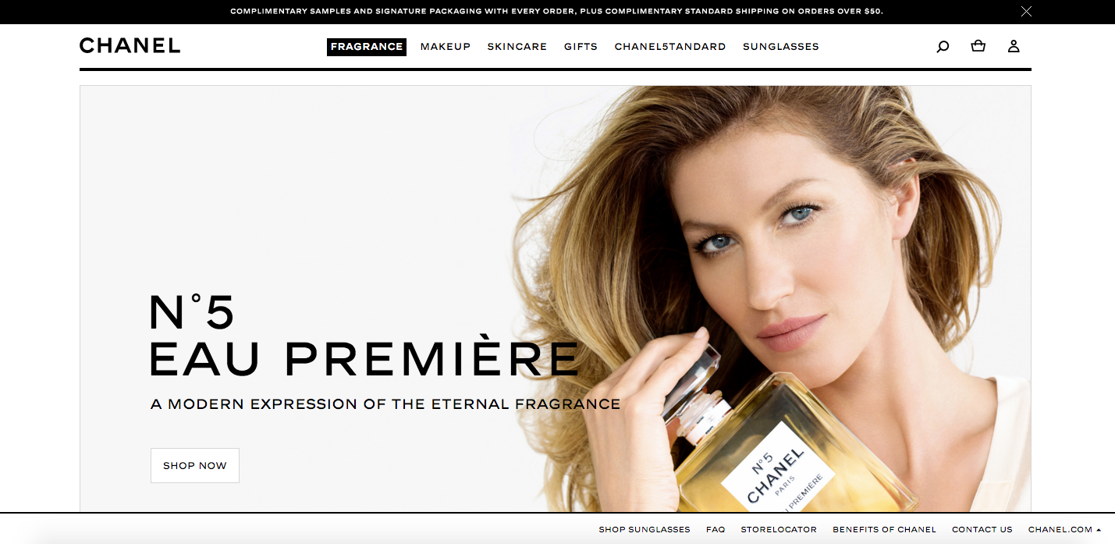

**Inspiration 2.0 Inspiration 3.0**

Navigation / Styling: Careers:

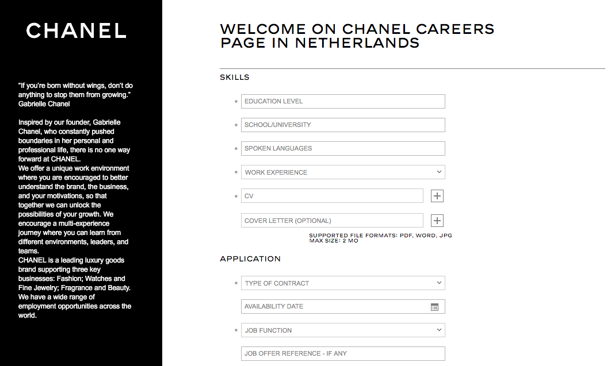

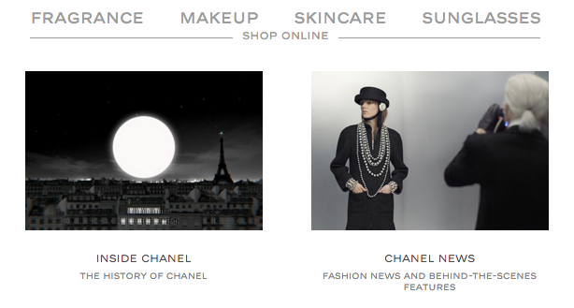

**Inspiration 4.0**

Slider:

**Inspiration 5.0**

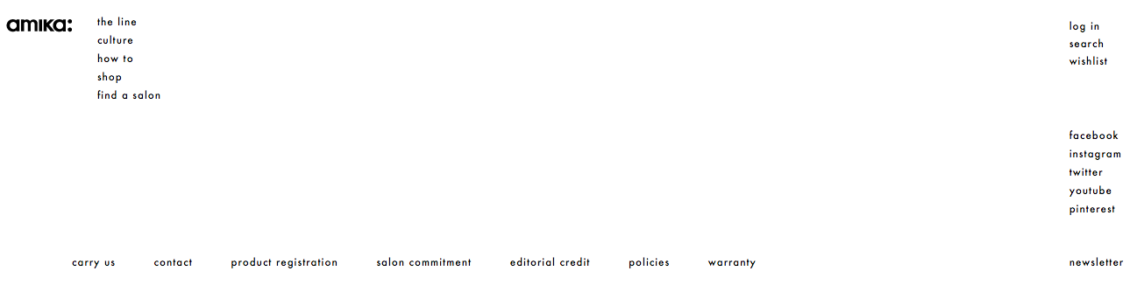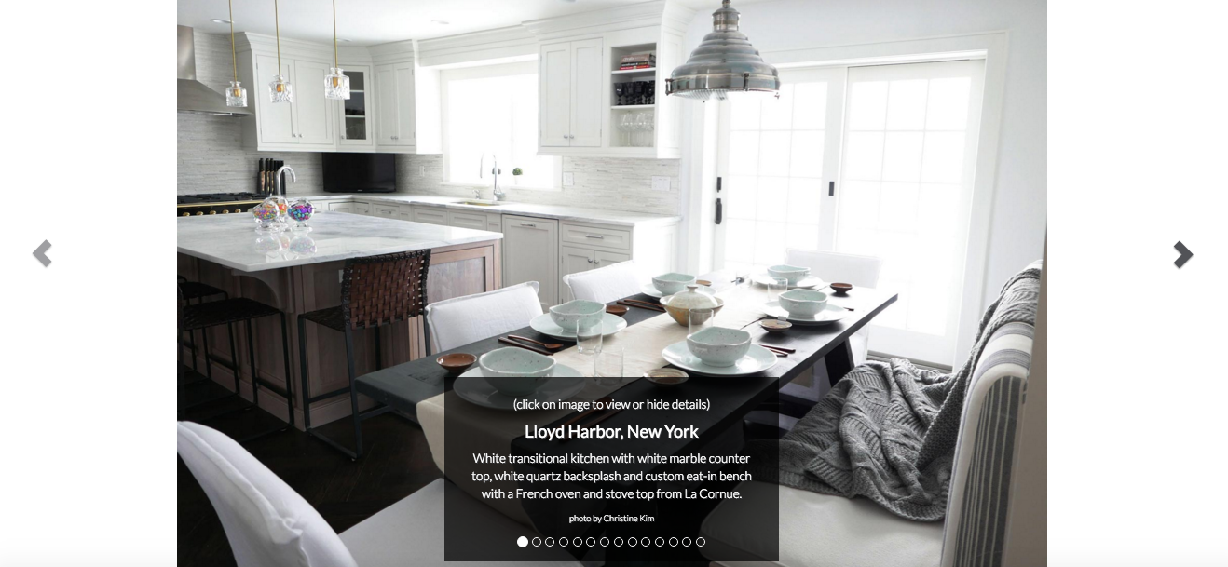 Navigation:

**Inspiration 6.0**

Page Lay-Out / Slider / Use of Colors:

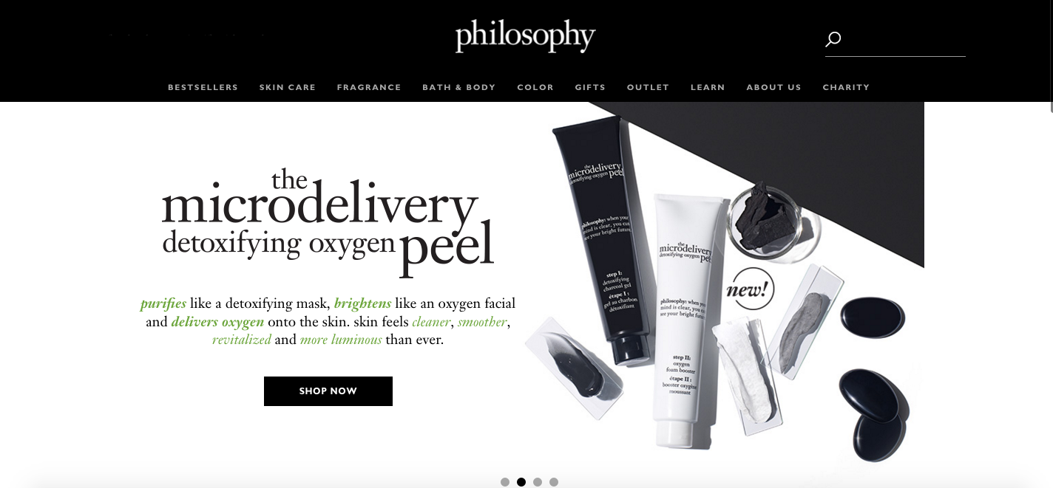

**Inspiration 7.0**

Font / Text Styling:

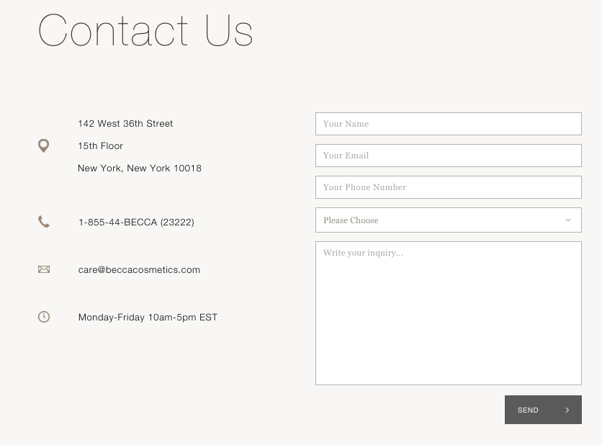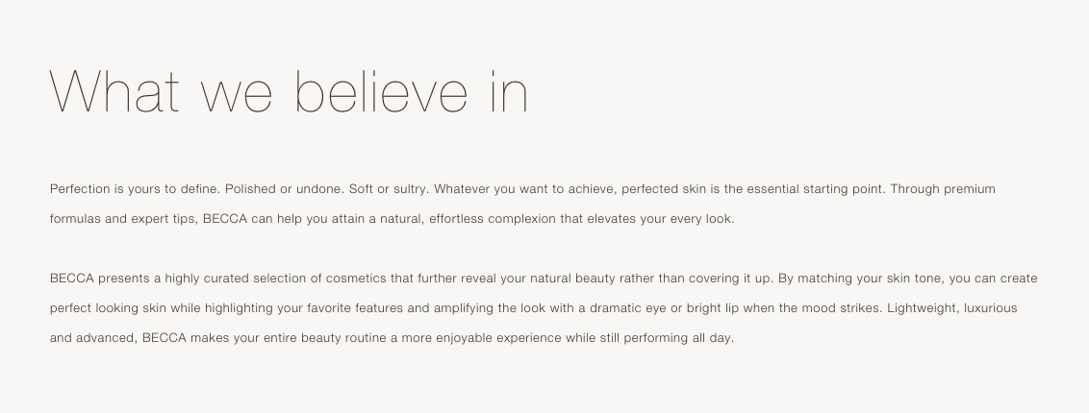

**Inspiration 8.0**

Contact Form:

**WIREFRAME SKETCH**

